

SNAKE VENOM BENEFITS



SNAKE VENOM BENEFITS

MONOCLED COBRA
Neurotoxic
Coagulant
Helps with heart issues, heals the lungs and works on the brain. Very calming and grounding. Brings clarity of thoughts, brings focus and slows down excessive over thinking, brings one to the present moment. Very good for mental issues such as depression, anxiety, memory (Alzheimer's, Parkinson's), addiction, and strokes. It repairs neural pathways in the brain and also affects the nervous system.

WATER MOCCASIN
Cytotoxic
Coagulant
Blood cleansing, anti-viral, anti pathogenic. Helps with STDs. It helps to free up joints, pain relievers, and muscle relaxers. It's great for skin issues, brings out feminine energy and helps with womb issues.

COPPERHEAD
Hemotoxic
Anti-coagulant
Kills tumors, cancer (especially breast), helps with clots.Frees up blood in joints.Deals with memory receptors and nervous system, helps with strokes, also affects the endocannabinoid system.

FER DE LANCE
Hemotoxic
Neurotoxic
Coagulant
Helps with brain and colon cancer cures hepatitis c, great for the skin, eczema, psoriasis, blemishes etc. Considered to be the fountain of youth, makes one feel more attractive, helps deal with overcoming fear (shadow work). It also helps with the womb, balances hormones, great for thyroid, good for anemia, cleanses the blood cells from parasites, viruses and bacteria.

BUSHMASTER
Hemotoxic
Coagulant
Works on the brain, gives a new sense of confidence and strength. It's a libido booster for men, makes one feel like a warrior. Good for restorative care after surgery. Cell regenerative, great for injuries, hepatitis c, urinary tract, liver, kidneys, bones and bladder.

GABOON VIPER
Cardio toxic
Neither anticoagulant or coagulant
Very grounding and relaxing, works on the heart and strengthens it, great for circulation, regulates high and low blood pressure, opens the heart chakra. One becomes more compassionate and loving, great for those who have had a heart attack or regulating the off rhythm of the heart.

WESTERN DIAMONDBACK RATTLESNAKE
Hemotoxic
Cytotoxic
Coagulant
Helps with Parkinsons, very energetic, moves the kundalini energy, cleans the blood. Good for physical and spiritual sight, skeleton system and is very objective.
GREEN MAMBA
Venom: neural toxin and cardio toxin neither coagulant or anti coagulant
- Good for kidney disease, supports in meditation
- Clears ancestral trauma
- Deals with shadow work
TIMBER RATTLESNAKE
Venom: cardio toxins, hemotoxin, neurotoxin, cytotoxin primary anti coagulant
- Type 2 diabetes
- Works on the brain, the heart the blood and all major organs
KING COBRA
Venom:neurotoxin, cardio toxin and cytotoxin, primarily anti coagulant
- Affects the central nervous system
- Good for MS and Parkinson's disease
- Good for joint pain, arthritis
- Works on the nerves
- Works on heart and lungs
- 10x stronger than monocled cobra

SCORPION

• Venom: High in neurotoxin
- Antiviral
- Anti Cancer
- Male and female reproductive issues
- Used as a topical and oral solutions
- Used against herpes, cold sores and HIV
- Assist with root chakra issues
- Has the antiviral benefits like the water moccasin and also has peptides that cleans the neurological pathways.
• Benefits: Pain relief, antimicrobial, antifungal, anti-inflammatory, antioxidant, and anti-cancer properties. Used for improving focus, and sharpening senses.

● Unlocking Nature’s Secrets: Sacred Animal Venoms for Healing and Growth”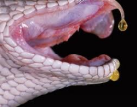

● Explore the Ancient Wisdom and Modern Practices at The Psychonaut Academy of Detroit
What is a Sacred Animal Venoms Practitioner?
A Sacred Animal Venoms Practitioner is a specialized healer who harnesses the profound transformative powers of animal venoms—such as those from snakes, frogs (Kambo), the Bufo alvarius toad, and scorpions—to facilitate deep spiritual, emotional, and physical healing. At the core of this practice is a commitment to guide individuals through transformative experiences that foster profound insights and promote character growth and development.
Our practitioners are not only experts in the safe administration of these potent substances but are also skilled facilitators of the integration process. This means they provide continuous support as clients navigate the profound revelations and changes initiated by their experiences. Through this journey, clients often encounter profound spiritual awakenings, accelerated personal development, and significant improvements in physical wellness.
At The Psychonaut Academy of Detroit, our practitioners are dedicated to fostering an environment of safety, respect, and deep understanding, ensuring that each individual’s journey with sacred animal venoms is enlightening and transformative. Join us to explore the profound healing and expansive potential that sacred animal venoms can offer under the guidance of our experienced practitioners.
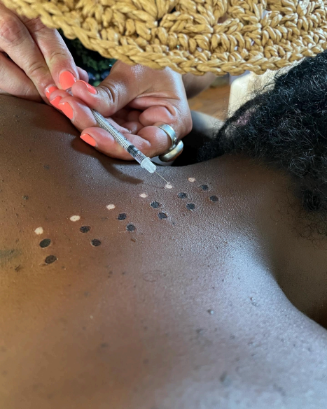
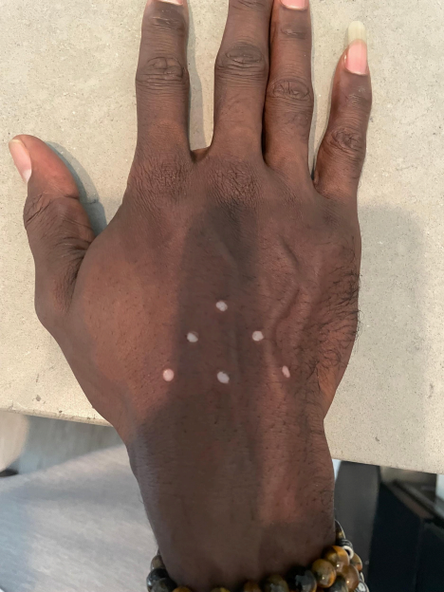
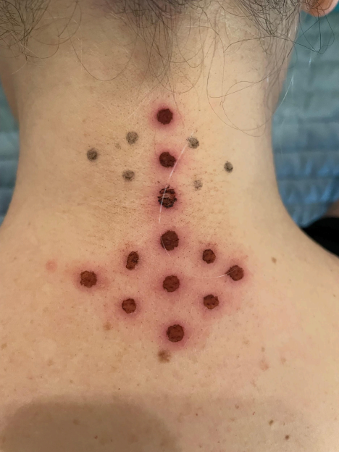
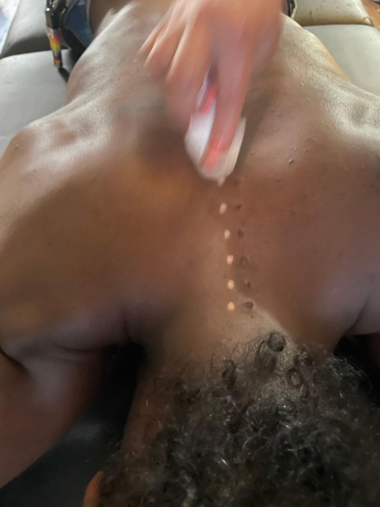
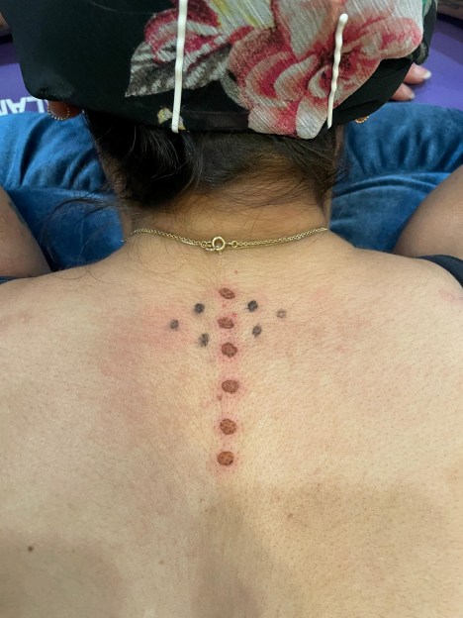
How do we use the Sacred Venoms?
At The Psychonaut Academy of Detroit, we utilize sacred animal venoms to catalyze profound transformations in three key areas of well-being: character growth and development, spiritual practices, and physical wellness.
1. Character Growth and Development: Our sessions are designed to foster resilience, enhance self-awareness, and promote personal growth. By experiencing the profound effects of venoms, individuals confront their inner challenges and limitations. This confrontation often leads to breakthroughs in personal development, helping clients cultivate qualities like courage, empathy, and patience.
2. Spiritual Practices: Sacred venoms serve as potent tools for spiritual awakening and enlightenment. The profound experiences they facilitate can lead to significant spiritual insights, a deeper connection with the self, and an enhanced sense of unity with the universe. These experiences are often transformative, offering new perspectives on life’s purpose and one’s place in the cosmos.
3. Physical Wellness: The therapeutic properties of animal venoms are harnessed to address various physical ailments and enhance overall well-being. From detoxification and immune system enhancement (Kambo) to pain relief and neurological stimulation (snake and scorpion venoms), these substances are applied in a controlled and safe manner to promote healing and physical health.
Our approach is holistic and integrative, ensuring that the benefits extend beyond the immediate experience. Each session is carefully prepared and followed by an integration process, where clients are supported in making sense of their experiences and translating them into actionable changes in their daily lives.
By leveraging the sacred venoms in these focused ways, we aim to unlock the full potential of each individual, fostering a balanced growth that encompasses mind, body, and spirit.
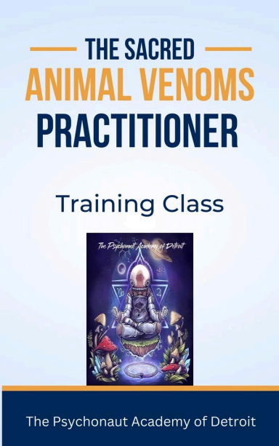
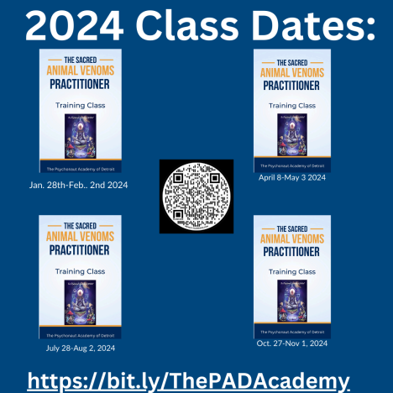
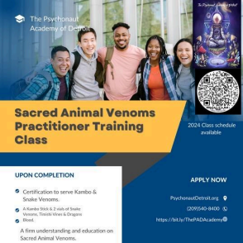
How to Receive Training as a Sacred Animal Venoms Practitioner
Embarking on a journey to become a Sacred Animal Venoms Practitioner is a profound commitment to healing and personal growth. To begin your training, please follow these steps:
1. Visit Our Website: Access HouseofGenesis.Org to find comprehensive information about our training programs.
2. Inquiry Submission: Navigate to the “Sacred Venoms Inquiry” section of our website. This area is specifically designed to provide you with all the details you need to understand the scope and depth of our training.
3. Provide Your Contact Information: Enter your email address in the designated field. This will enable one of our knowledgeable and courteous team members to reach out to you.
4. Follow-Up Communication: After your inquiry, you will receive an email containing all the necessary information regarding our training programs. We will also schedule a follow-up call to gather your intake information and discuss your path forward.
By following these steps, you will be well on your way to becoming a skilled practitioner, equipped with the knowledge and tools to use sacred animal venoms responsibly and effectively.

